Environmental Policy Statement

Contract Plant are committed to the protection of the Environment and will control its activities in such a manner to avoid causing unnecessary or unacceptable damage or pollution. The importance of this objective is given equal status with other essential business aspects and has received endorsement at senior management level.

To achieve this goal the Company will:

- Comply fully with all relevant environmental legislation, codes of practice, guidance and industry best practice.

- Provide a framework for setting Environmental objectives and the continual improvement of our EMS to enhance our environmental performance.

- Develop environmental awareness and individual responsibility at all levels throughout the organisation.

- Encourage full and effective consultation on environmental matters with our employees.

- Provide appropriate training on environmental issues where a need for such training is identified.

- Prevent nuisance to the local community and to avoid damage to the environment.

- Where possible Reclaim and recycle materials and substances used in our operations.

- Dispose of any waste arising from our business activities in the most environmentally acceptable way possible.

- Service and maintain our plant and equipment in such a way that they operate at maximum efficiency and give optimum fuel consumption.

- Routinely monitor our environmental performance to ensure company objectives remain aligned.

Approved By:
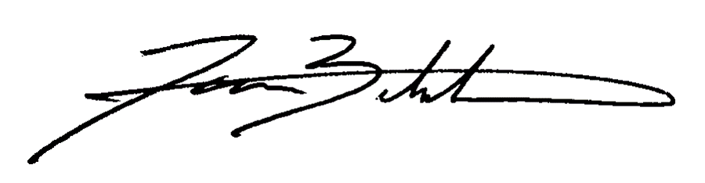
James Bickerton
Managing Director

